Project Management
Megan Vasquez
December 22, 2013
MGMT 505: Project Management Fundamentals
Dr. Darrin DeReus
Southwestern College Professional Studies

Kerzner Office Equipment
Headquartered in Charleston, South Carolina, Kerzner Office Equipment began manufacturing and selling high-end office furniture and equipment in 2004. By 2009, 1,400 employees were enjoying Kerzner’s growth and success. However, the recession had devastating effects on the company and Kerzner was forced to lay off more than 25% of its personnel to stay in business. When the new CEO, Justin Tubbs, was introduced, Kerzner began to see improvements. Tubbs offered an altruistic, caring attitude and organized operations around a “team” mentality. Soon after, Kerzner teams introduced a new ergonomic furniture line that proved to be a raving success and earned the company an industry-leading status. Today, Kerzner ranks as one of Charleston’s Post and Courier’s top 10 companies to work for in South Carolina. Justin Tubbs is committed to continuing the momentum of Kerzner’s revival. In best efforts to show appreciation for his now 1,100 employees and team dedication, he has asked the Human Resource Department to organize Kerzner’s 10th anniversary celebration.
The Current Situation
3:00 | Introductions
3:15 | Project Overview
3:30 | Ground Rules
3:45 | Meeting Times
4:00 | Adjourn
David Brown, Vice President of Human Resources, named Amber Briggs the Project Manager for Kerzner’s celebration event. Briggs, a Human Resource Specialist, is excited to lead a high-profile project on her own. In a hurry, Briggs individually contacts each of her fourteen team members to inform them of the project kickoff meeting. Figure 1.1 demonstrates Briggs’ posted agenda for the meeting.
Figure 1.1: Briggs’ Meeting Agenda

Unfortunately, the kickoff meeting was poorly planned and even more poorly executed. In her rush, Briggs failed to collect necessary information, provide adequate meeting space, or achieve full attendance. Statements from Briggs such as, “If we screw up, everyone will know about it,” offer a negative project tone and can be perceived as threating. Furthermore, most attendees lack real motivation for the project. For instance, Nick Psias was forced to attend the meeting because it was “his turn” and Mike Wales was volunteered by his boss because operations were slow in his department. While this is the first meeting, these small hurdles may balloon into larger problems. Indicators of functional-management support have already surfaced. Amber Briggs struggled to generate communication with her team members for introductions, schedules, or motivational brainstorming. The team has ten weeks before needing to make a formal presentation to the CEO. In this time, the team must organize the event and a plan for properly allocating their budget of up to $150,000.
While the kickoff meeting was adjourned on time, Briggs failed to accomplish agenda items including a project overview and meeting times. After the meeting, Amber has a plan to meet with each team member individually. Amber has asked that each person submit availability schedules and event ideas in an effort to help plan future meetings.
It should be noted; Amber Briggs had a few strengths to her meeting. First, she acted quickly with motivation and intent. Second, she prepared a basic agenda that covered her meeting purposes. Finally, Briggs contacted each individual team member prior to the meeting. With each of these, she displayed enthusiasm and drive for the anniversary project. In theory, these are great traits of a skilled project manager. However, Amber could have capitalized on each of situations to have a successful, purposeful meeting.
What needed to happen?
Preparing for a kickoff meeting should be planned much like the project itself. Amber Briggs was in such a rush to gather the team that she missed several opportunities while doing so. First, she needed to have a private space for the meeting that enables team members to openly discuss and brainstorm the project. Delaying the meeting one day would have allowed for her to secure an adequate location. Secondly, Briggs individually contacted team members to inform them of the meeting. In these conversations, she could have easily addressed the following:
  - meeting availability,
  - individual strengths,
  - And participant constraints.
Preparing a meeting schedule in advance would have eliminated much wasted time during the kickoff meeting and prevented Amber from leaving the meeting without such important scheduling information. Assessing strengths could have allowed Briggs to assign project roles in advance. And addressing participant constraints, such as Ingrid Hedstroms 30-day absence, could help eliminate or correct issues prior to the kickoff meeting. Finally, motivating employees is difficult to accomplish with a blank slate. Briggs could have researched event locations, brainstormed various themes, and outlined major event expenses to present at the meeting to encourage new ideas and project discussion. Preparation for a kickoff meeting is vital for organization, information delivery, and expectation management.
Amber Brigg’s meeting could have been more organized as well. In fact, Michael Sisco (2013), an expert in project management, suggests there are nine steps to executing an effective project kickoff. First, prepare a basic agenda. While Briggs did present a basic agenda, it did not address project goals, individual roles, plans, or milestones. The agenda could have also included a project name and expectations. Keeping the meeting motivational and on task is Sisco’s second step. Briggs’ negative threats could have been reorganized as a motivational pep talk suggesting that “everyone will be talking about how great the event turned out.” She should have also as stayed on time with agenda (despite its noted deficiencies). Larson and Gray (2011) further note that kickoff meetings should be started on time despite attendance. Punctuality must be demonstrated and expected from the start of the project. Steps three and four introduce the project manager, the team, and project highlights. This may have been the only aspect Amber Briggs successful accomplished. Although, it would have been beneficial to assign project roles as well. Next, Sisco suggests the project manager set up a periodic meeting. While Briggs’ intentions were to address meeting schedules, lack of discussion participation ultimately put this on hold. Empowering the team is Sisco’s sixth step where he would invite individuals to take responsibility for their roles and tasks. Poor planning precluded Amber from reaching this step. Deterioration of participation distracted Amber and prevented her from addressing the final three steps: set expectations for project communication, answer questions, and set clear expectations and milestones for future meetings (Sisco, 2013).
Constraints
Amber Briggs can already identify notable constraints that might present risks within the project. The first is lack of motivation. Only three of the team members displayed some excitement toward the project while others were forced to attend the meeting. Driving forces for lack of motivation may include task saturation, timing limitations, the absence of project vision, and objectives. Many of team members may also grossly underestimate the importance or complexity of event planning in a corporate setting and thus consider the project meetings a waste of time. Michael Vennerstrom (2013) reports that organizational event planning is an, “underutilized and misunderstood strategic tool in professional America” (Vennerstrom, 2013, p. 1). While many consider events as fruitless expenses, Vennerstrom assures that properly planned occasions, such as Kerzner’s celebration, is an opportunity to build invaluable relationships.
Briggs will be taking team members away from their departments which equally create constraints for functional managers. Having the support of functional managers and creating a balance of utilized time is a challenge Amber must overcome in order for team members to bring motivation and focus to the project. Functional managers may not have historically considered event planning as project management. William O’Toole (2003) assures us otherwise. He suggests that corporate events managed like a traditional project allows for greater communication, consistent terminology, organization, and familiarity (by comparison) to other projects (O’Toole, 2003). Further, if team members are not motivated and managers disregard the importance of time dedicated to the project, Briggs will be facing uncontrollable hurdles.
Two additional constraints will present risks in this project: communication and scheduling. Vennerstrom stresses that communication not only makes an effective event possible but also helps the company understand the true value offered by special events. Measurable goals, well-defined messages, and clear strategies will be required to execute Kerzner’s 10th anniversary celebration (Vennerstrom, 2013). Finally, Briggs will need to develop an efficient process for effective communication that allows all team members to be updated in real time.

Required Resources
Time is Amber Briggs’ most valuable resource while planning the company party. Not only does the team have limited time to organize the event, but team members are concurrently working on operational projects. A scheduling software tool and a communication system will aid in properly managing time. Having concise and consistent meetings will also minimize wasted efforts. Another resource required for this project is a sizable budget. CEO Tubbs has allocated up to $150,000 for the anniversary party. While at first glance this amount may seem to be ample, it must be kept in mind that Kerzner has 1,100 employees. The following unknowns and more, in regards to budget, will also need to be addressed:
$ Will families be invited? | $ Will the dinner be plated?
$ How long will the event last? | $ Is the event all-inclusive?
$ Will alcohol be served? If so, will it be provided free?
Finally, team members’ motivation, organization, communication, and ideas will serve as valuable resources as well as functional-management support. Without the input from the team (and other employees), Briggs may miss the mark and fail offer a celebration aimed at demonstrating appreciation for the employees. Further, functional managers may strictly limit time spent on the project.
Resource Responsibility
The responsibility of properly balancing time between operational projects and the Kerzner anniversary party will be in the hands of both Amber Briggs and the individual team members. It may be beneficial for Amber to distribute e-mails to functional managers outlining the project objective, the importance of the event (name-dropping the CEO), and need for employee input. Courtesy-copying her director may provide leverage or, at the very least, validity to CEO Tubbs’ endorsement. Functional managers may appreciate being updated, the consideration of operational projects, or the ability to add ideas – the party is for employee appreciation after all.
Without first assigning project roles, Briggs will not be able to adequately distribute other resources such as budget allocation. As an outside consultant, it would be recommended Amber collect schedules, individual strengths, and constraints. Then, she should develop a schedule and assign roles. Finally, she can begin to distribute resources the appropriate personnel.
Project Timeframe
CEO Tubbs is expecting a formal presentation on planning and budgeting concerns within the next three months. Amber Briggs has asked her team to prepare the presentation within ten weeks. While the celebration event will not be complete in either of these timeframes, the bulk of the planning needs to be done. Figure 1.2 demonstrates the many event-planning activities Amber Briggs has to consider at this time.
- Location | - Date | - Entertainment
- Food Service (plated or buffet) | - Food | - Invitees
- Decoration | - Speakers | - Marketing
- Music | - Beverages | - Door Prizes
Figure 1.2: Event Considerations

Briggs’ project timeline will need to address the various chronological concerns using both a project network path and a backward pass timing method. She will start by identifying dependent activities in their chronological order while also identifying critical paths and parallel activities. Next she will allocate associated time beginning with the last activity, the formal presentation to top management and ending with the first activity, deciding who to invite (employees alone or employees with families). Figure 1.3 depicts a suggested backward pass activity network that Amber could use to organize her time and priority.
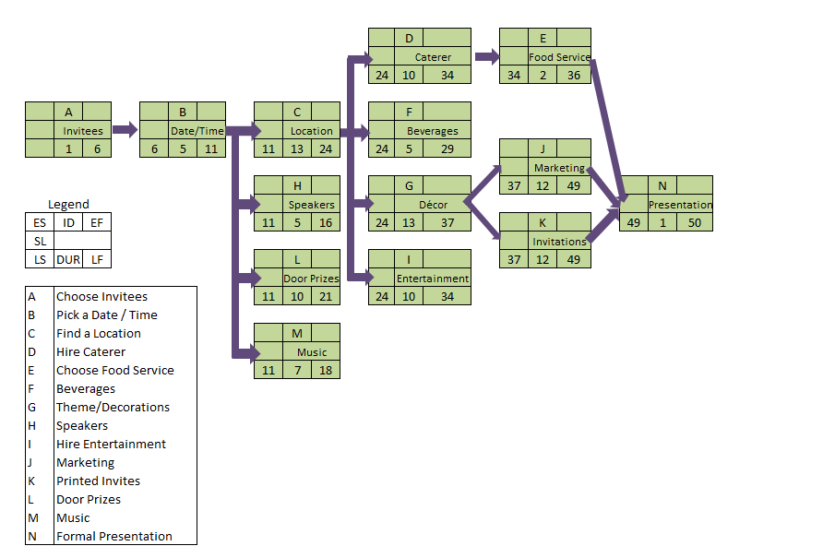Figure 2.3: Backward Pass Activity Network
Two critical paths should be noted in the activity network. Both identifying the event location and developing marketing and invitations will need to be accomplished on time in order for the project to progress as planned.
Estimates and Associated Costs
The Kerzner Anniversary Celebration Team will need to first determine how many people to expect. The organization employs 1,100 people and the event is voluntary. Sharron Campbell, Certified Meeting Professional, suggests that for first-time, voluntary events plan on 85% of invited guests showing (Campbell, 2011). Thus, the team can expect 935 employees will attend the event. The Pew Research Center suggest that 51% of Americans are married (Frazier

935 Employees
720 Guests
1,655 Total
O’Brien, 2011) and relationship studies suggest 53% of single employees may bring a date (Jayson, 2012). Thus, the team may reasonably expect an additional 720 guests will attend, totaling 1,655 estimated guests in all.
After setting a date for the celebration, finding an appropriate reception space will be the next important activity and the bulk of the budget. Sharron Campbell (2011) estimates each person attending the event will require nine to ten square feet per person. Thus, Amber Briggs and team will need to look for available reception halls that are roughly 15,000 square feet or larger in order to have good flow amongst the guests. Selection will be limited as few spaces such as the Ballroom at the Embassy Suites Convention Center in Charleston, SC have the capacity to hold 1,655 estimated guest. Of course, hotel and reception sites commonly require the use of in-house caterers offering little room for cost negotiation. However, these sites also come inclusive with tables, chairs, linens, silverware, plate settings, glasses, ice, and housekeeping that other do-it-yourself locations lack.
Finally, Amber Briggs will need to address proper cost considerations. The location, food, and beverages will consume most of the finances. Given the $150,000 budget, the team can spend no more than $90 per person. All-inclusive location reservation costs range from $11,000 - $23,000. Basic dinner buffets for convention locations such as the Embassy Suites Convention Center start at $40 per plate; plated dinners range from $38-$46 consuming half of the budget in food alone. At the same location, an open bar serving beer and wine for four hours will cost and additional $30 per person (Embassy Suites, 2013). Calculating just food and beverage, the costs are exceeding the budget. Amber will have to explore various options for controlling costs to include:
- Reducing the time of the event
- Considering a cocktail reception rather than a plated dinner
- Not including guests as invitees
- Planning the event for a weekday (frequently reduces costs)
- Having a cash bar
- Using Kerzner’s own facility
It may be beneficial for Amber to explore partnerships with clients. Maybe an office owner who purchases Kerzner’s furniture would be willing to rent out their space in exchange for a discount. Keeping the team’s options open would certainly aid in stretching the budget.
Return on Investment
Those who think that return on investment would be omitted for a special event are missing an opportunity. While it is not as obvious to calculate, many successful events return the investment. The quickest way to gauge the celebration is to assess the attendees. The amount of attendance, the quality of attendance, and the response from the attendees will help determine ROI. For a special event such as Kerzner’s anniversary party, return can be generated through retention, new client leads, inspiration/motivation to employees, and media coverage. Finally, the response from management will indicate how strong the event was and may encourage future operational decisions (Cavanaugh, 2011).
Risk Assessment
Amber Briggs has many risks to clearly identify, analyze, and ultimately mitigate before this project really kicks off. The primary risks are:
- Lack of Team Motivation
- Inconsistent Schedules
- Poor Communication
- Lack of Support from Functional Managers
- Exceeding the Budget
Amber Briggs conducted a risk analysis and charted its results in Figure 1.4:
Risk Event |  | Likelihood | Impact | Detection Difficulty | When
A | Lack of Motivation | 3 | 3 | 1 | Start Up
B | Inconsistent Schedules | 4 | 3 | 1 | Throughout
C | Poor Communication | 4 | 5 | 4 | Throughout
D | Lack of Support from Functional Managers | 3 | 3 | 3 | Start Up
E | Exceed Budget | 3 | 5 | 3 | Throughout
Figure 3.4: Risk Analysis
This risk analysis demonstrates five risks with a moderate to high degree of impact. Next Briggs will develop a Risk Severity Matrix to help determine which risks she should prioritize. The Risk Severity Matrix will rank each risk (A through E) according to both likelihood and impact; impact having the greater weight of the two. Figure 1.5 demonstrates Amber’s risk-severity results.
Likelihood | 5 |  |  |  |  |  |  |  | Major Risk
 | 4 |  |  | B |  | C |  |  | Moderate Risk
 | 3 |  |  | A  D |  | E |  |  | Minor Risk
 | 2
 | 1
 |  | 1 | 2 | 3 | 4 | 5
Impact
Figure 4.5 Risk Severity Matrix
The Risk Severity Matrix reflects (B) inconsistent schedules, (C) poor communication, and (E) exceeding budget, all present major risks while (A) lack of motivation and (D) lack of support from functional managers present moderate risks. Amber will need to create plans to mitigate all risks and develop contingency plans in the event the risk threatens the project objectives. Thus, Briggs develops a risk response matrix to help clarify her responses to each risk. Figure 1.6 reflects the results of such assessment.
Risk Event | Response | Contingency Plan | Trigger | Who is Responsible?
Motivation | Mitigate: Discuss celebrated accomplishments (why are we having this party!?!) | Take team to party site, have caterers deliver sample food. Make the experience “real” | Lack of participation, first deadlines not met, low meeting attendance | Amber Briggs
Schedules | Mitigate: Pre-determine meeting schedules | If everyone cannot make the meeting, have smaller meetings with only leads | Low attendance after 2nd meeting | Amber Briggs
Communication | Mitigate: Break out into teams, have 1 lead per team. Leads will be in charge of disseminating communication | Have a central place for all project changes, updates, info, etc. | Miscommunication after 2nd meeting | Team Leads
Support from Functional Managers | Mitigate: Communicate lack of support with David Brown, head of Human Resources | Report to CEO Tubbs | Low attendance after 3rd meeting. | Amber Briggs
Exceed Budget | Mitigate: Read fine print, get all quotes inclusive of tax and fees, seek out many options to reduce costs, seek out exchanges with clients for event services. | Cut invitations, marketing, open bar, and some décor from event. Also, shorten the event if possible | Start considering cuts if at any point we are 10% over budget | Amber Briggs/Team Leads
Figure 5.6: Risk Response Matrix
Using the Risk Response Matrix, Amber has plenty to do before her next meeting. She will first use the team’s schedules to build a meeting schedule that will achieve the highest attendance. Next Amber will break the team into groups in order to tackle individual activities. Larger groups will be responsible for finding the location and reserving door prizes while smaller groups will be looking internally for guest speakers and researching music options. Amber will assign a lead to each of these groups to ensure streamlined communication and aligned schedules. Finally, Amber will research Kerzner’s personnel and team accomplishments (specifically those that involve team members). She will use this information to remind team members of how Kerzner’s raving success should be celebrated and rewarded. If possible, she should ask CEO Tubbs to join the meeting and share his gratitude to the employees.
Tracking Progress
The Kerzner Celebration formal presentation is mere weeks away. Amber Briggs must stay on schedule to ensure the project is progressing as expected. She has chosen to use a Gantt chart to track progress. Figure 1.7 depicts the project activities, their associated timeline (as suggested by the backward pass schedule), and who is responsible for the tasks. Groups 1 and 2 are larger, thus have the greater responsibilities and critical paths on the project. 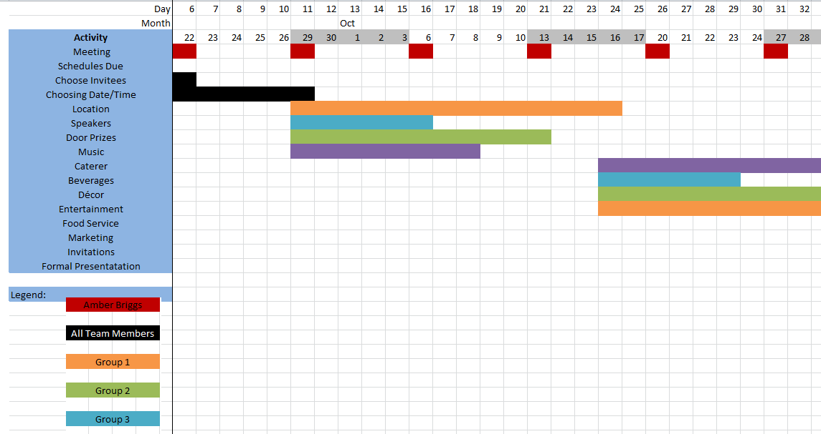Figure 1.7: Gantt Chart
As the Gantt chart demonstrates, there is some slack in time with many activities. This should not be misleading as there is not such slack in the project overall. Amber Briggs will need to keep the groups on track and accomplish activities as planned to be best prepared for the team’s formal presentation to CEO Tubbs.
Conclusion
Amber Briggs must redeem herself after the Kerzner’s Anniversary Celebration first meeting. Otherwise she risks losing motivation, and consequently, participation in the high-profile project. Future meetings will need adequate space, clear communication, organization, and overall enthusiasm in a project that celebrates her peers’ accomplishments. In order to do this, Amber will need to concentrate on adequate planning and scheduling. Further, she needs to organize groups within the project that have similar schedules to tackle the projects required activities.
The next ten weeks will present several challenges that might risk the project’s vital resources: time, budget, motivation, organization, and communication. Briggs planning must address timing considerations and dependent activities. In addition, the projects costs must be appropriately allocated to activities. As Amber Briggs assesses these risks and their impact, she will offer strategic mitigation and responses to each one. Finally, she will create a Gantt Chart to track progress of activities, timelines, and individual group responsibilities. Sufficient planning will help ensure Amber Briggs’ future project meetings and activities run smoothly with intent, objective focus, and motivation.

References
Campbell, S. (2011). How to estimate space requirements for meeting and event set-ups. Planning Helper. Retrieved from http://www.planninghelper.com/spv-207.aspx
Cavanaugh, J. (2011). ROI metrics: Analyzing the top 10 measurement tools. Special Events. Retrieved from http://specialevents.com/corporate-events/roi-metrics-analyzing-top-10-event-measurement-tools
Embassy Suites. (2013). Events: It’s your wedding. Retrieved from http://www.charlestonconventioncenter.com/wp-content/uploads/2013/04/Its-Your-Day.pdf
Frazier O’Brien, N. (2011). Percentage of Americans who are married reaches all-time low, Pew says. Catholic News Service. Retrieved from http://www.catholicnews.com/data/stories/cns/1104976.htm
Jayson, S. (2012). Many singles looking for love, but not marriage. USA Today. Retrieved from http://usatoday30.usatoday.com/news/health/wellness/story/2012-02-02/Survey-gives-a-snapshot-of-singles-in-America/52922248/1
Larson, E.W. & Gray, C.F. (2011). Project Management: The Managerial Process (5th ed.). New York, NY: McGraw-Hill Irwin.
O’Toole, W. (2003). Using a Project Management in Event Management. Project Management Journal. Retrieved from https://ehis.ebscohost.com/ehost/pdfviewer/pdfviewer?vid=5&sid=3a4b8e19-bd4f-4ff1-bd61-cd5caca4e496%40sessionmgr4004&hid=4108
Sisco, M. (2013). Lead a project kickoff meeting that spells success. Teamwork, 20 (5). Retrieved from https://ehis.ebscohost.com/ehost/detail?vid=4&sid=a52108b5-0b6d-48f9-839f-5a2543847d6b%40sessionmgr115&hid=115&bdata=JnNpdGU9ZWhvc3QtbGl2ZSZzY29wZT1zaXRl#db=b9h&AN=87619311
Vennerstrom, M. (2013). How corporate event planning drives business success. Crains New York Business. Retrieved from https://ehis.ebscohost.com/ehost/detail?vid=10&sid=a52108b5-0b6d-48f9-839f-5a2543847d6b%40sessionmgr115&hid=115&bdata=JnNpdGU9ZWhvc3QtbGl2ZSZzY29wZT1zaXRl#db=bwh&AN=90239405

